Scope statement
To facilitate BizOps (“the company”)’s vision and business objectives, this project will focus on the planning, design and implementation of a Work Health and Safety Management System (WHSMS) for the company. Specifically, the system will be implemented to support the Head Office building expansion project (see Appendix 1).
As a support to this Project Plan, the Senior BizOps Managers have formally notified the team of aspects to be included in the WHSMS.
The following is a summary email (see Appendix 2) from CEO, Rose Hargreaves instructing the WHSMS project team to:
- Evaluate some of our current WHS policies and procedures;
- Develop other procedures and a record-keeping system that ensures the work area (and therefore the organisation) complies with WHS legislation; and
- Be responsible for maintaining and evaluating the WHSMS throughout the life of the project.
The WHSMS project team will consider current risk management, financial planning, growth plans and organisational structures when delivering the WHSMS. These will be summarised in the following sections of this document.

Executive summary
The WHSMS has been designed to align well defined and understood company goals. In conjunction with the outlined vision (see Appendix 3).
The planned expansion of the Head Office building is supported by the WHMHS through rigorous risk management, financial prudence and operational effectiveness.
Planned profit re-investment allocated from business budgets (see Appendix 4) will be utilised in the WHSMS.

Business objectives
Key growth targets are set at 15% per annum with reinvestment plans detailed in the Budget Assumptions section of this document. The company is looking to affirm risk management processes and increase safety, efficiency and, ultimately, profit margins.
Current business planning identifies the following key measure of success
- Exceptional product and service quality;
- Time-efficient and cost-effective development processes; and
- Expert and knowledgeable staff.
It is considered in the scope that support of the external retail networks from a continuously improving Head office function is critical to these factors, specifically focused on:
- Maintaining a unique selling position;
- Anticipated demand;
- Pricing strategy;
- Value to customer; and
- Growth potential.

Project description
As detailed in Appendix 1, the Head Office construction project (works) will:
- Employ workers across a range of occupations and trades and equipment;
- Engage employees, contractors and subcontractors in the works; and
- Manage public exposure and vehicle access to the works.
The tasks detailed for the creation of the WHSMS in this report will include:
- Confirming legislative requirements;
- Identifying relevant roles and responsibilities;
- Resourcing the WHS management system;
- Establishing appropriate induction and training;
- Providing participation and consultation arrangements for establishing the WHS management system;
- Developing processes for identifying and resolving issues; and
- Implementing hazard and risk control procedures that ensure legislative compliance.
The WHSMS must also provide a mechanism for evaluating the ongoing effectiveness of the processes, which you and your WHSMS team will put in place.
Key assumptions
- Financial resources are allocated in full for the WHSMS and the works;
- Designs and appropriate permitting for the works are is complete;
- State legislation is applicable; and
- Key internal stakeholders & resources are identified and available to the project team – HR, Finance, Sen Mgt.

Roles and project stakeholders
This table refers to the company’s current organisation chart (see Appendix 7):
Role | Responsibilities
Project Sponsor (Chief Executive Officer) | Final approval of WHSMS, Financial expenditure. Final sign off on the policy, the procedure of guidelines
Budget Holder (Managing Director, Financial Operations) | Review of ongoing financial performance and key sign off on additional expenditure and invoicing
Senior Users (Managing Director, Human Resources) | Key decision maker and sign off on vertical areas of control. Key points of reference for area of specialism and sign off
WHSMS Project Manager | Project schedule control, performance management, Client representation and reporting
WHSMS Project Team Members | As per project tasks & schedule
Company WHS Professionals | As detailed in Resources Required

Time line
Task | Anticipated duration
Project planning and scheduling | 4 weeks
Works review (internal & external) | 2 weeks
Current work practices and procedures | 3 weeks
Legislation Internal systems review | 2 weeks
Finalise Schedule | 2 weeks
Key stakeholder engagement | 2 weeks
Project resourcing and readiness | 4 weeks
Project launch and roll out | 2 weeks
Hazard Identification | 3 weeks
Participation process design | 6 weeks
External stakeholder process design | 8 weeks
Reporting and monitoring process design | 4 weeks
Training and Induction program design | 4 weeks
WHSMS gap analysis | 3 weeks
Client final sign off and approval | 3 weeks
WHSMS implementation program | 6 weeks

Legislative requirements
The BizOps WHSMS will be developed in compliance with the following New South Wales legislation, regulations and standards: (source: https://www.business.gov.au/risk-management/health-and-safety/whs-oh-and-s-acts-regulations-and-codes-of-practice)
- Work Health and Safety Act 2011 (NSW);
- Work Health and Safety Regulations 2017 (NSW); and
- NSW Codes of Practice.
To ensure appropriate oversight of the implementation of requisite legislation, regulations and standards, consultation throughout the project will be undertaken with the following organisations:
- SafeWork NSW; and
- WorkCover NSW;
Other resources that may be referenced in the development of the WHSMS are detailed below:
- Your responsibilities as an employer or business;
- How we can help – free advice and support for businesses; and
- Employer and business obligations.

Resources required
The table below outlines the resource requirements for this project:
Personnel Resources | Other Resources
Project Sponsor (Chief Executive Officer) | Appropriate accommodation/work area the Project Team
Senior Users (Managing Director, Human Resources) | Information Technology hardware and software
Project Manager | Access to relevant legislation, regulations, standards and guidelines
Project Team Members
WHS Professionals (contracted as required)

Budget assumptions
Expense | Current Forecast
Human Resources (Project Team) | $120,000
Human Resources (WHS Professionals) | TBA
Accommodation | $60,000
IT/Hardware requirements | $45,000
Legislation/Standards/Regulations | TBA

Reporting requirements
The project manager will issue regular reports on progress against budget, schedule and scope, circulated to the following:
- Project Sponsor;
- Budget Holder;
- Senior Users; and
- Project Team Members;

Reporting will facilitate timely, regular advice to stakeholders, providing information on project progress, implementation, impacts and risks. This will assist stakeholders to determine the extent to which the project is meeting desired outcomes and will include a financial statement indicating expenditure and commitments to date.
The Project Manager may issue additional progress reports that provide an update on the status of the project, as required.

Authorities
The scope statement will be approved by:
- Rose Hargreaves; Chief Executive Officer;
- Sean Bamford; Managing Director, Business Operations; and
- Mike Booth; Managing Director, Financial Operations.

Project changes will be approved by:
- Rose Hargreaves; Chief Executive Officer;
- Sean Bamford; Managing Director, Business Operations; and
- Mike Booth; Managing Director, Financial Operations.

Project deliverables will be approved/accepted by:
- Rose Hargreaves; Chief Executive Officer;
- Sean Bamford; Managing Director, Business Operations; and
- Mike Booth; Managing Director, Financial Operations.

Sign Off

Rose Hargreaves  Chief Executive Officer |  | Sean Bamford  Managing Director  Business Operations |  | Mike Booth  Managing Director  Financial Operations

Appendix 1 – Building Expansion Project Background
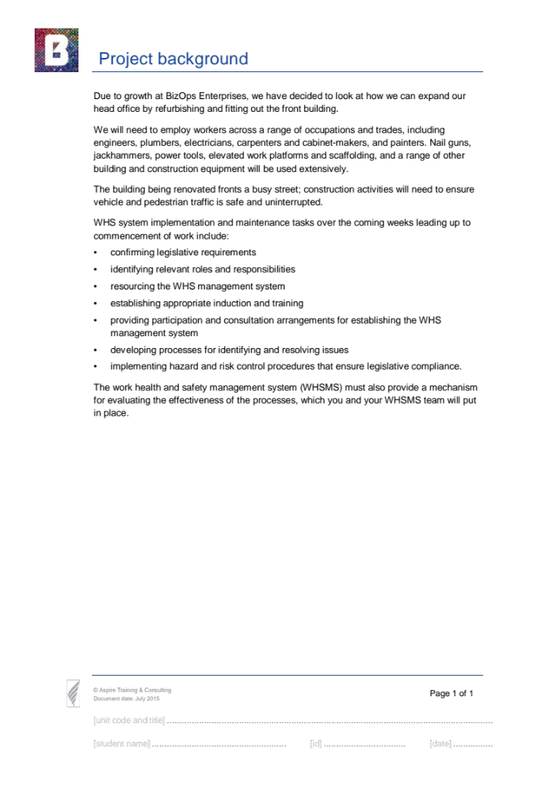
Appendix 2 – CEO Instruction
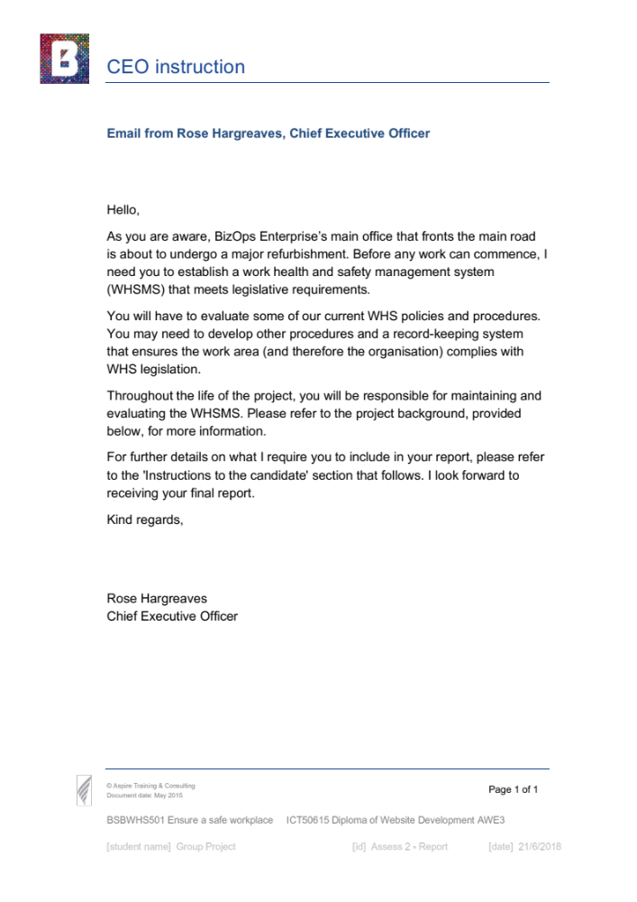
Appendix 3 – Vision, Mission and Values
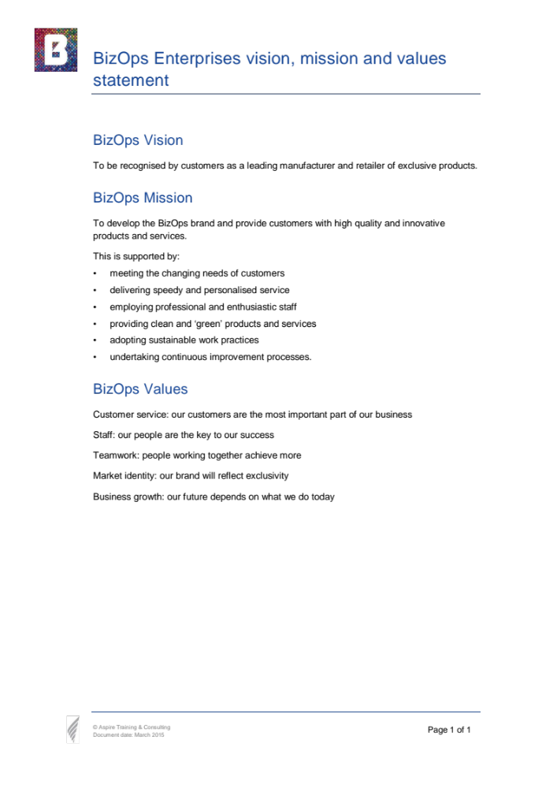
Appendix 4 – Company Business Plan (Page 1 of 7)
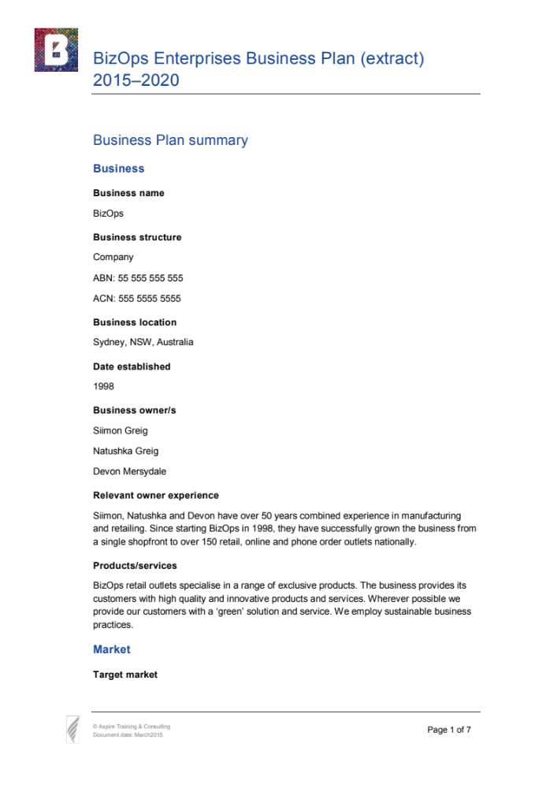
Appendix 4 (continued) – Company Business Plan (Page 2 of 7)
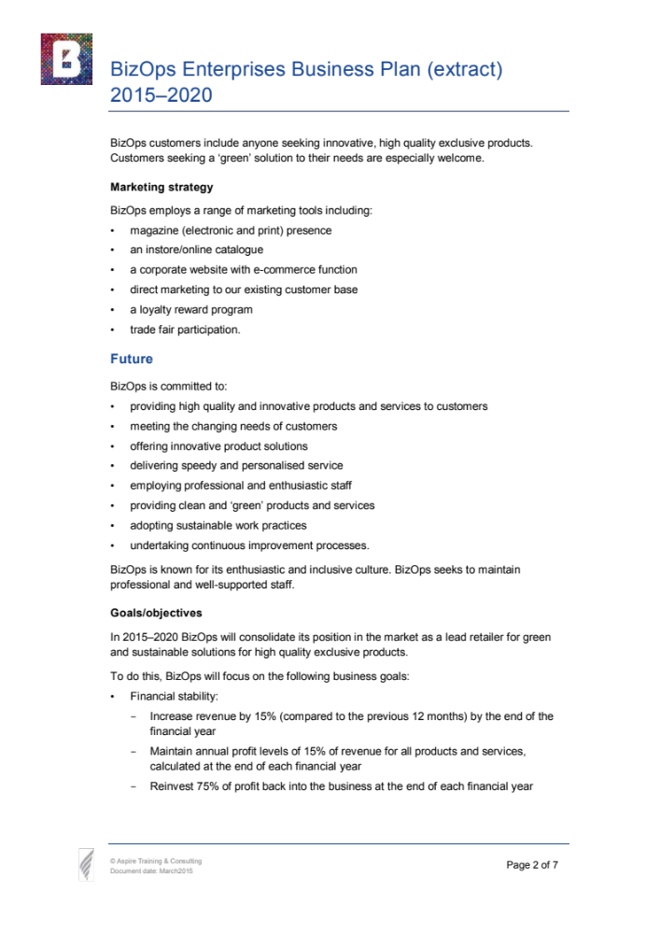
Appendix 4 (continued) – Company Business Plan (Page 3 of 7)
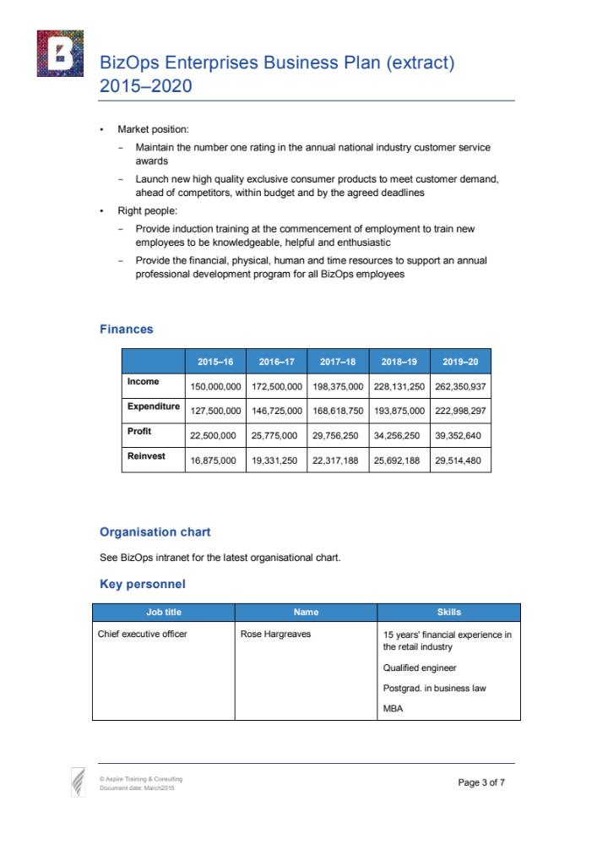
Appendix 4 (continued) – Company Business Plan (Page 4 of 7)
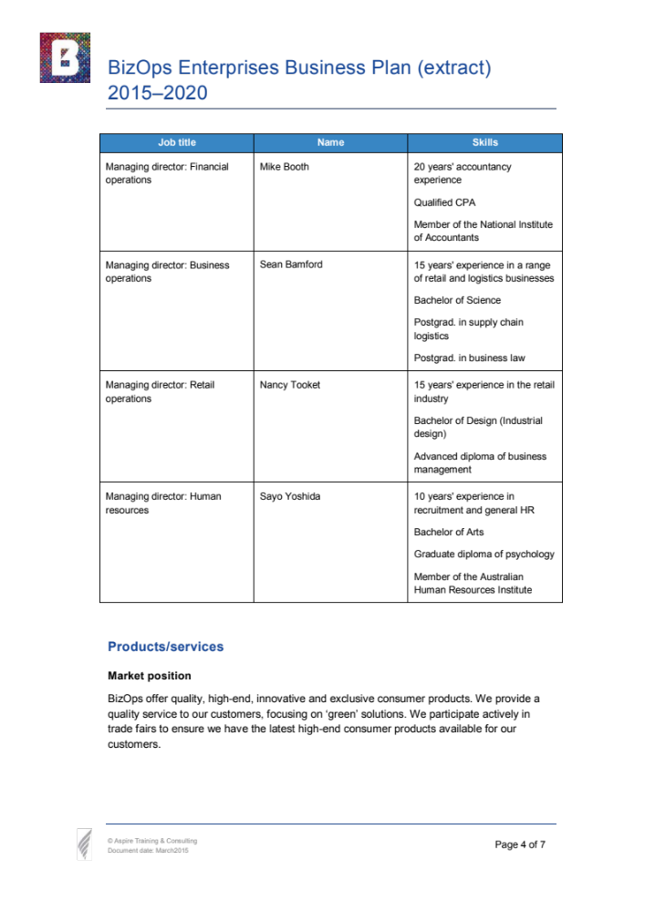
Appendix 4 (continued) – Company Business Plan (Page 5 of 7)
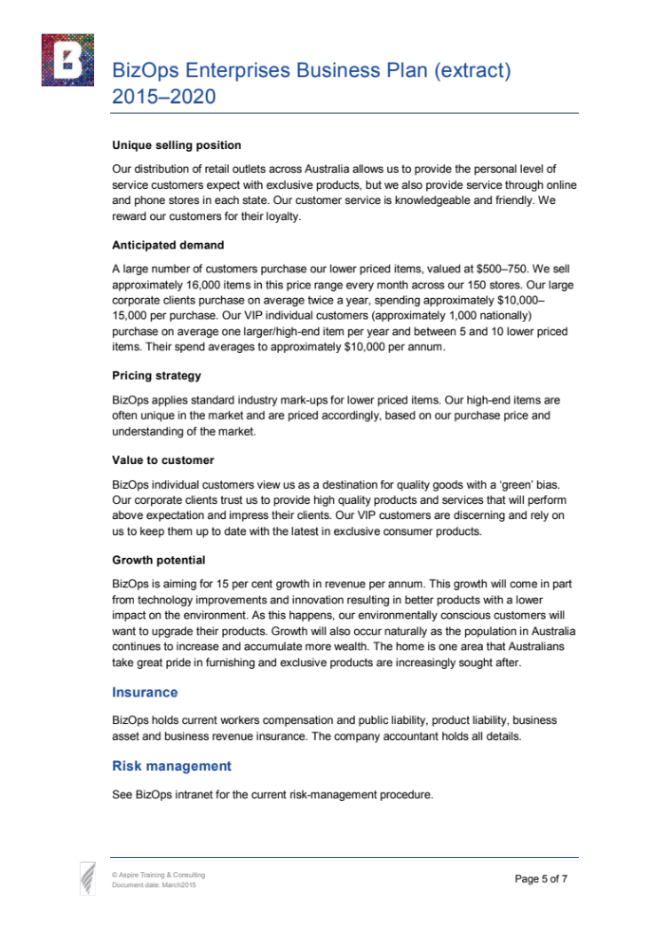
Appendix 4 (continued) – Company Business Plan (Page 6 of 7)
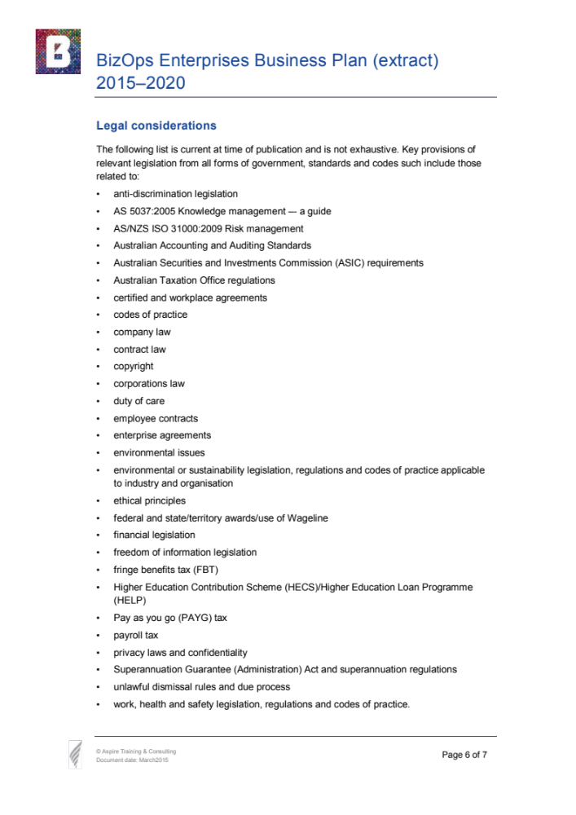
Appendix 4 (continued) – Company Business Plan (Page 7 of 7)

Appendix 5 – Risk Management Policy (Page 1 of 2)
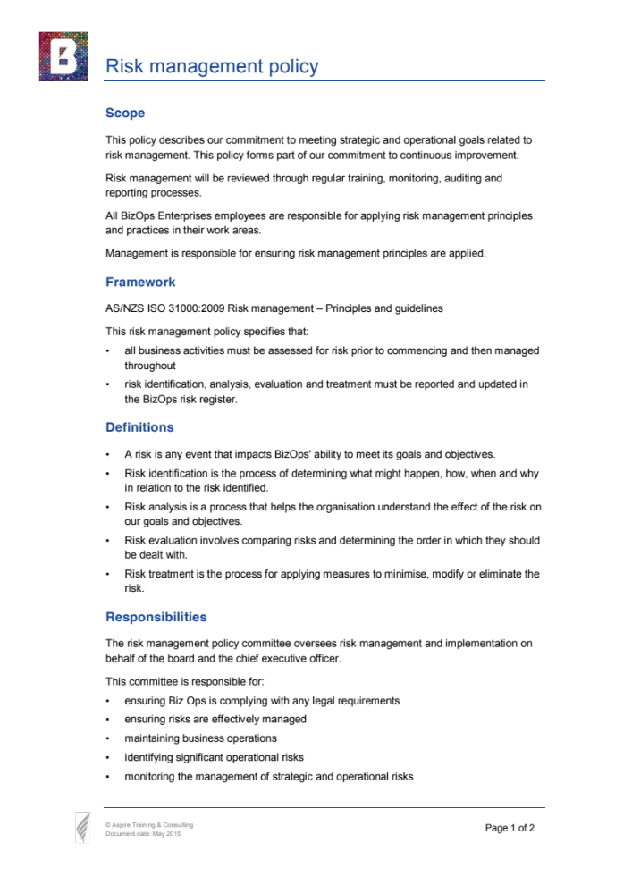
Appendix 5 (continued) – Risk Management Policy (Page 2 of 2)
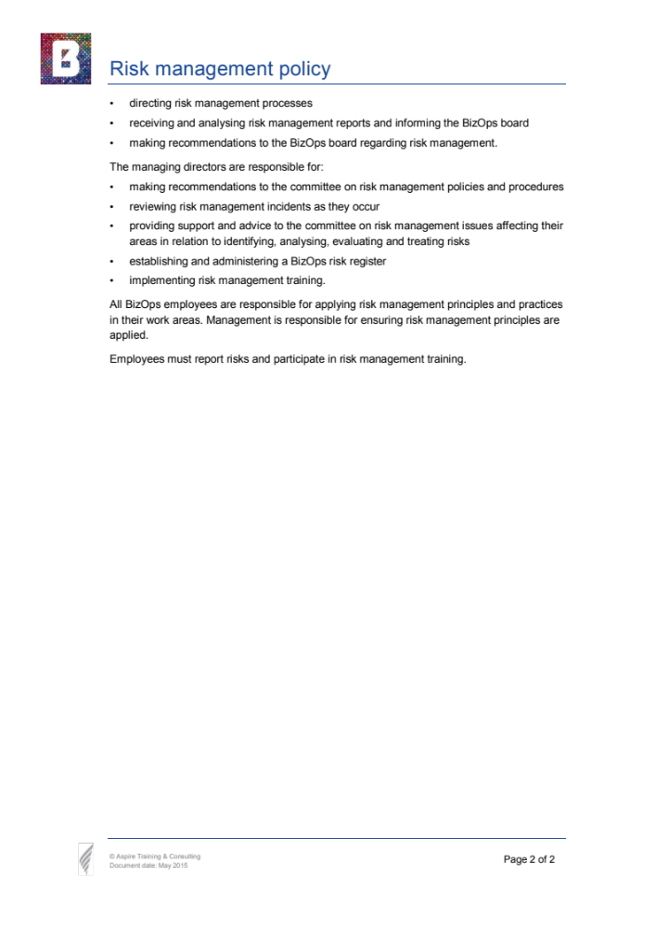
Appendix 6 – Risk Management Procedures (Page 1 of 6)
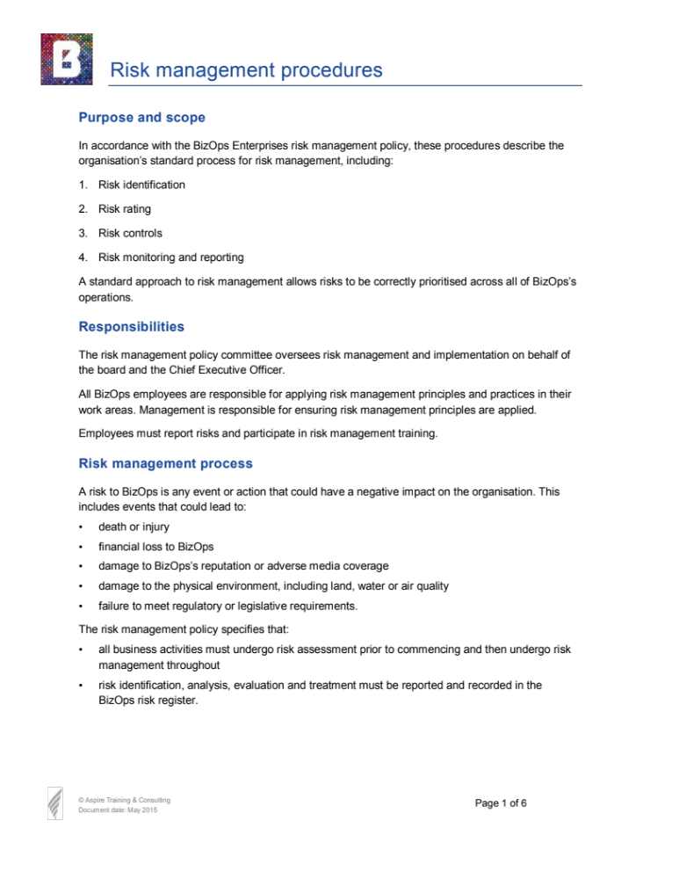
Appendix 6 (continued) – Risk Management Procedures (Page 2 of 6)
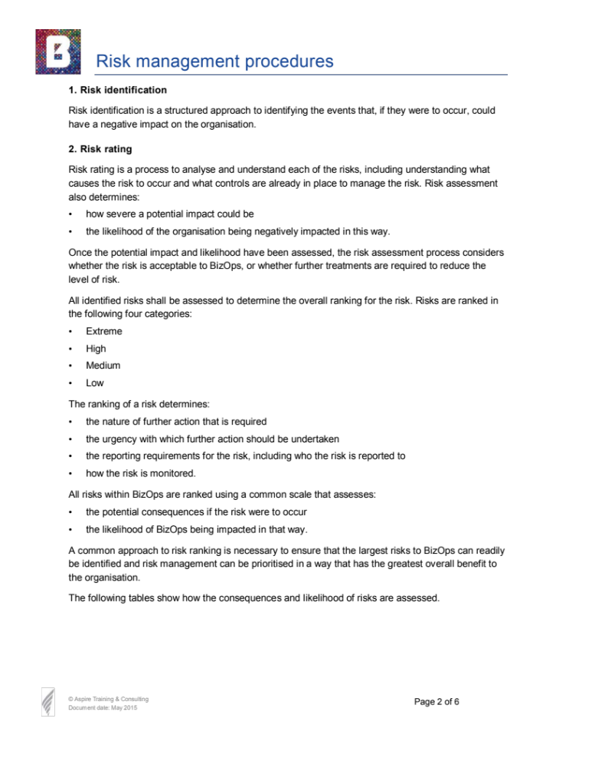

Appendix 6 (continued) – Risk Management Procedures (Page 3 of 6)
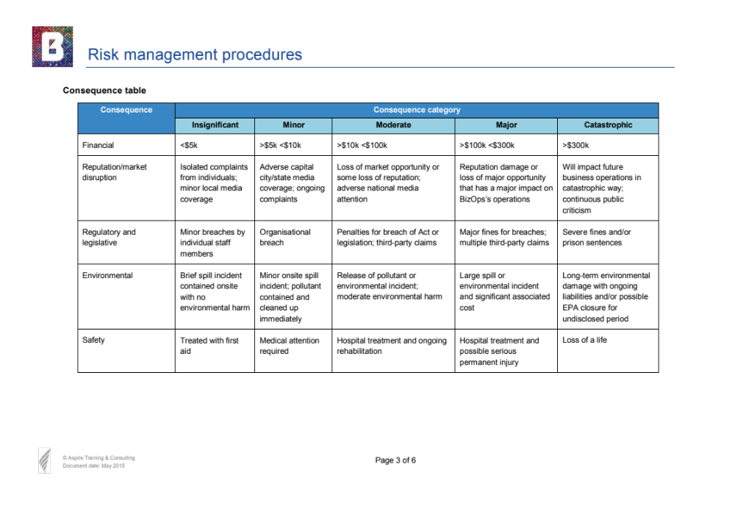

Appendix 6 (continued) – Risk Management Procedures (Page 4 of 6)
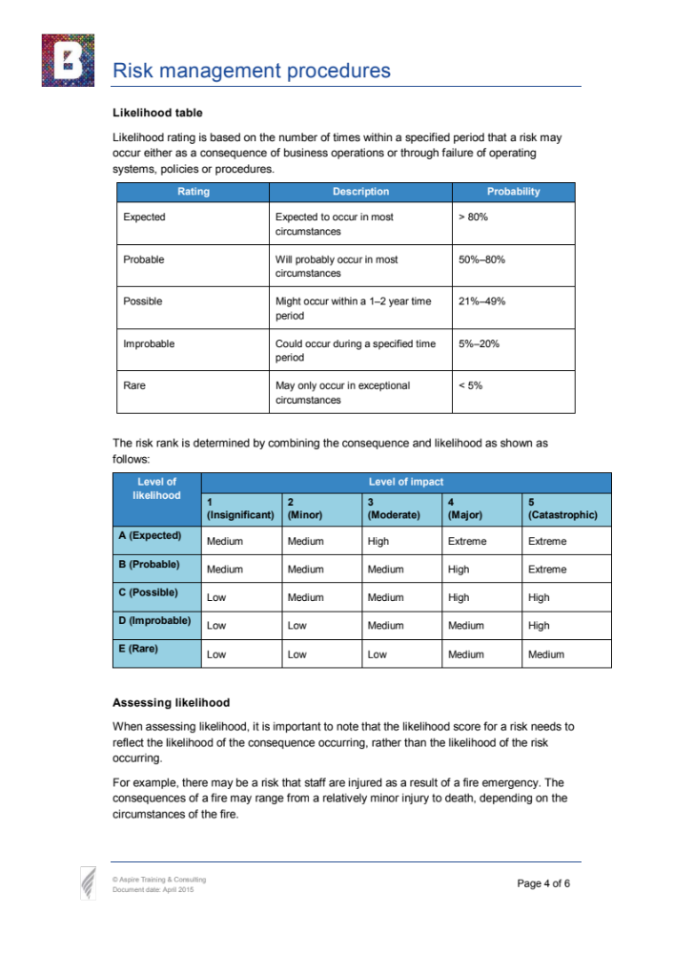
Appendix 6 (continued) – Risk Management Procedures (Page 5 of 6)
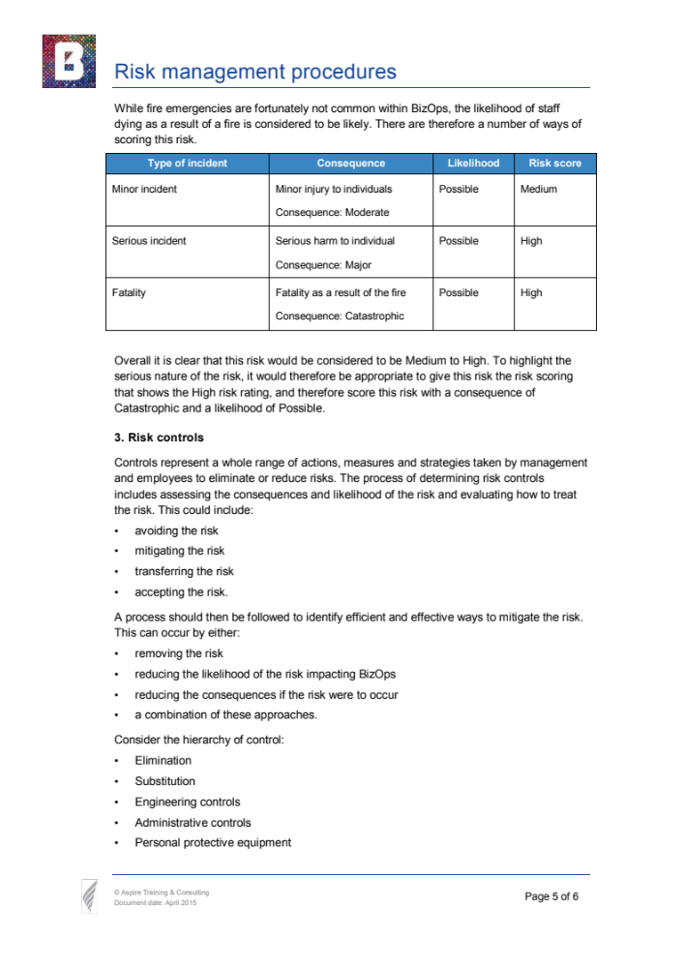
Appendix 6 (continued) – Risk Management Procedures (Page 6 of 6)
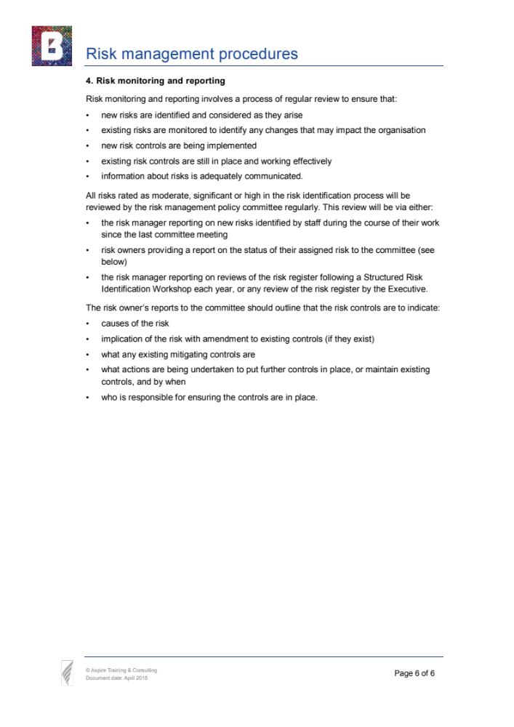
Appendix 7 – Organisational Charts
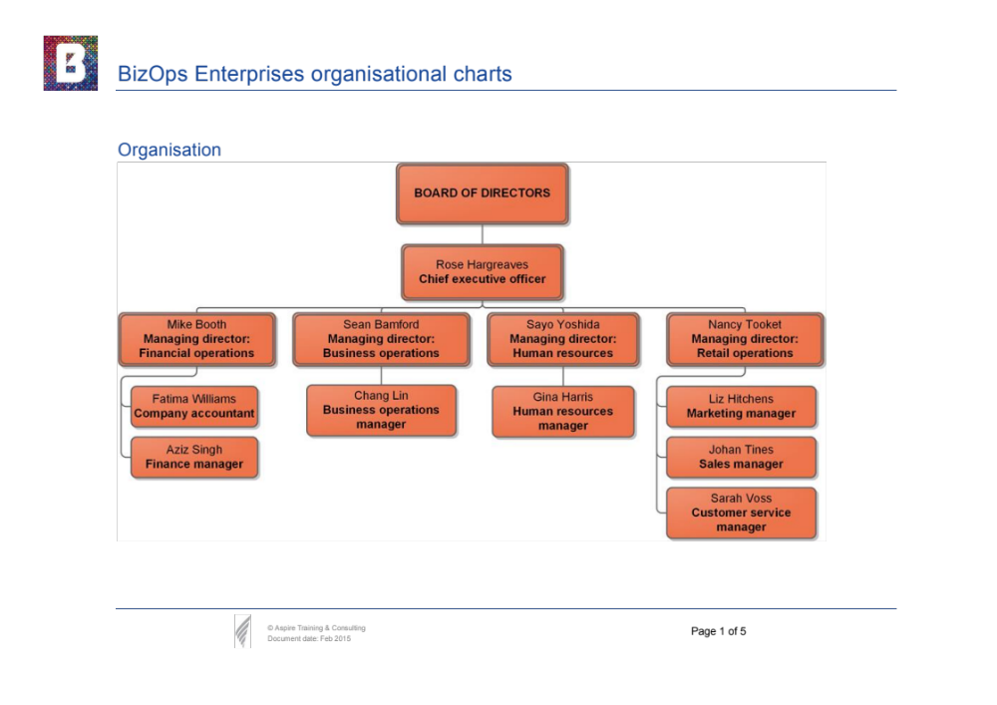
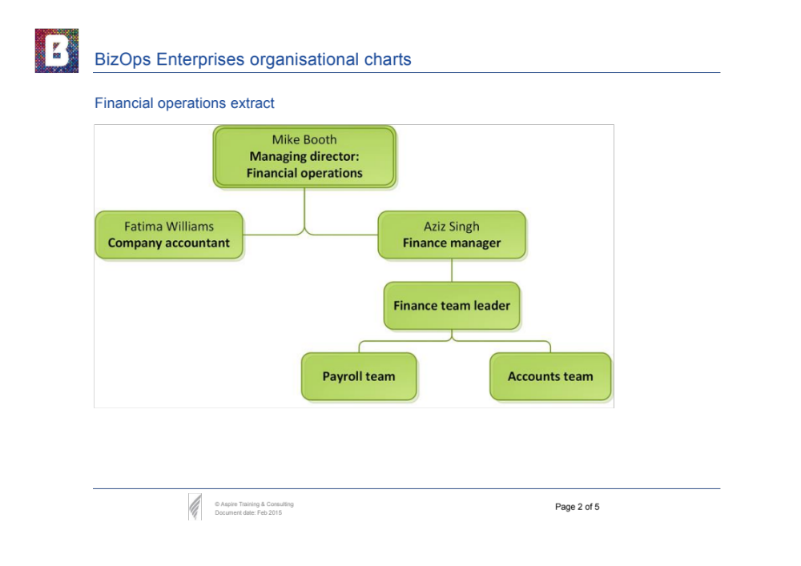
Appendix 7 (continued) – Organisational Charts
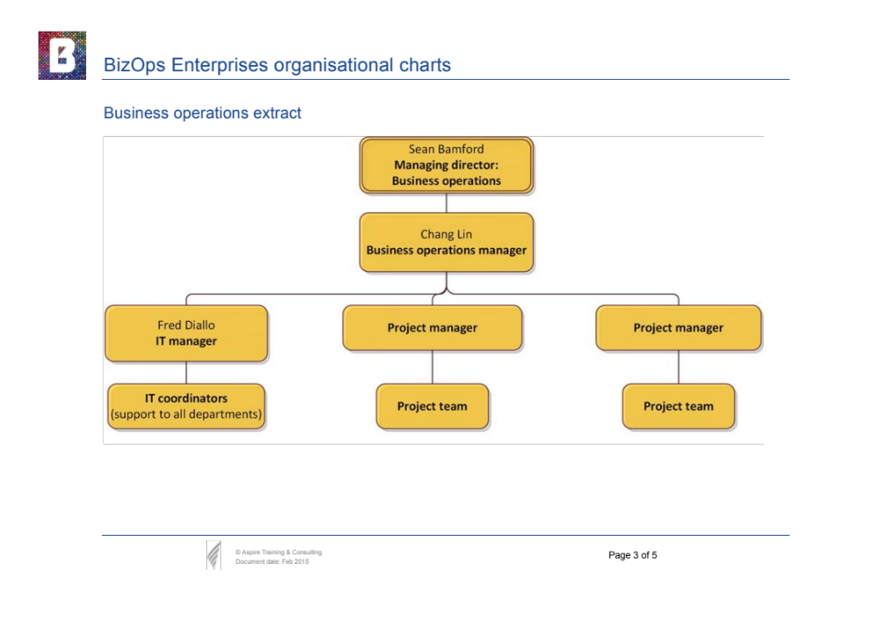
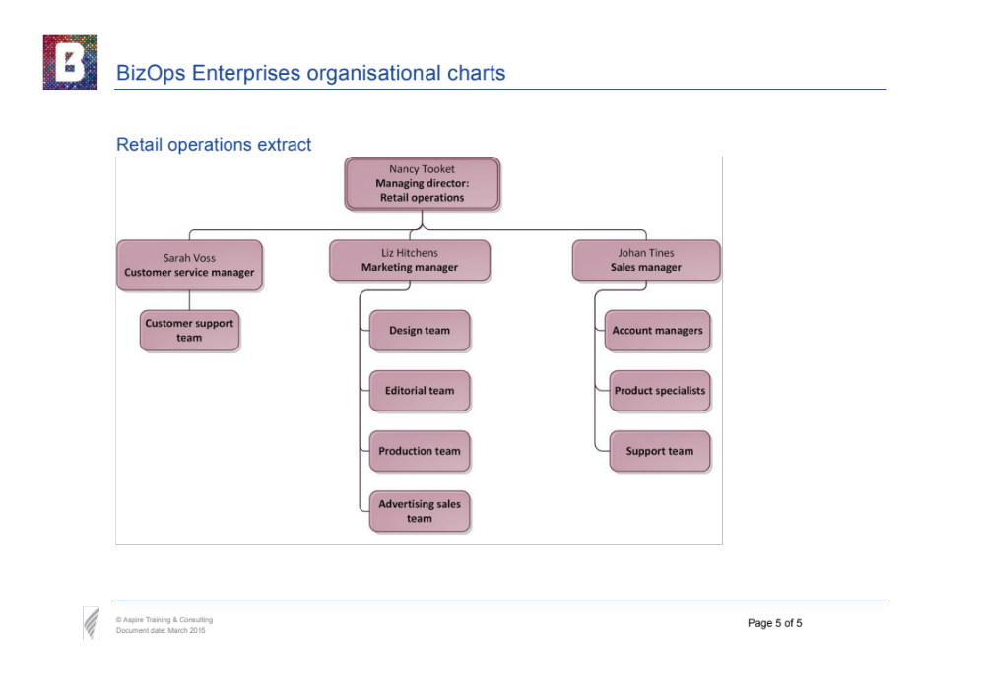
Appendix 7 (continued) – Organisational Charts
